**SOURCE CODE MANAGEMENT**

NAME:-ABHIJAY SHARMA

GROUP:-G01

ROLL NO:-2110990039



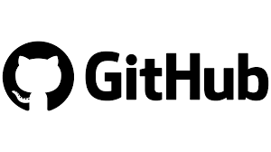

**INDEX**

|  |  |  |
| --- | --- | --- |
| **S.NO.** | EXPERIMENT NAME |  |
| 1. | **INTRODUCTION** |  |
| 2. | **SETTING UP OF GIT CLIENT** |  |
| 3. | **SETTING UP GITHUB ACCOUNT** |  |
| 4. | **USING GIT COMMANDS AND GENERATING LOGS** |  |
| 5. | **GIT BRANCHING** |  |
| 6. | **GIT LIFECYCLE DESCRIPTION** |  |



Git is a source code management technology used by DevOps. Git is a piece of software that allows you to track changes in any group of files. It is a free and open-source version control system that may be used to efficiently manage small to big projects.

Git is a version control system that allows numerous developers to collaborate on non-linear development projects.

Git is an example of a distributed version control system (DVCS) (hence Distributed Version Control System).

**What is GITHUB?**

GitHub is a version management and collaboration tool for programming. It allows you and others to collaborate on projects from any location.

GitHub is **an online software development platform used for storing, tracking, and collaborating on software projects**. It enables developers to upload their own code files and to collaborate with fellow developers on open-source projects.



A repository stores all of your project's files, as well as the revision history for each one. Within the repository, you may discuss and monitor your project's progress. The .git/ subdirectory within a project is a Git repository. This repository keeps track of any changes made to files in your project over time, creating a history. That is, if you delete the.git/ subdirectory, you are also deleting the history of your project.

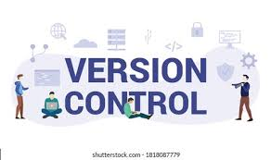

Version Control Systems are the software tools for tracking/managing all the changes made to the source code during the project development. It keeps a record of every single change made to the code. It also allows us to turn back to the previous version of the code if any mistake is made in the current version. Without a VCS in place, it would not be possible to monitor the development of the project.

SETTING UP OF GIT CLIENT

For git installation on your system, go to the linked URL.

<https://git-scm.com/downloads>

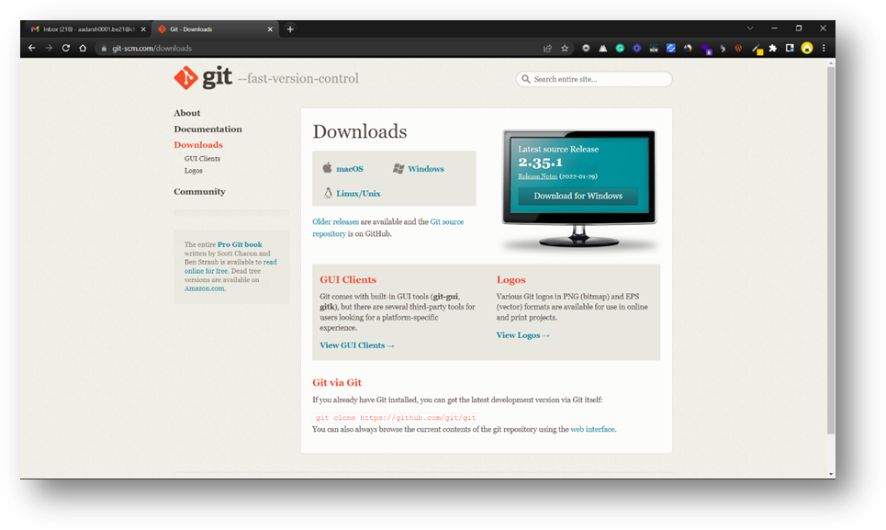

You must first access this webpage and then choose your operating system by clicking on it. I'll walk you through the processes for the Windows operating system in this article.

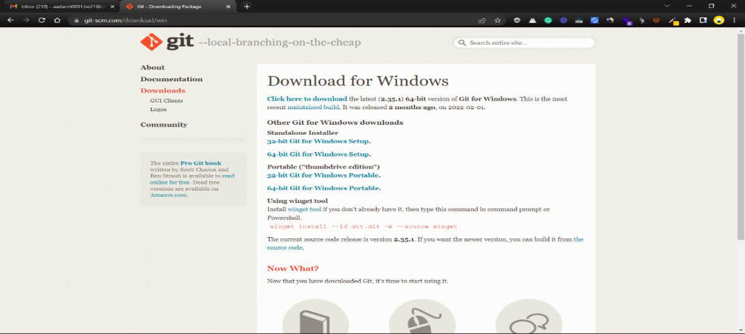

Select the CPU for your system now. (Most of the system now runs on 64-bit processors.) Your download will begin when you pick a processor.



You must now open the Git folder.

You will be asked if you want to enable this program to make modifications to your PC once you launch it.

YES should be selected.

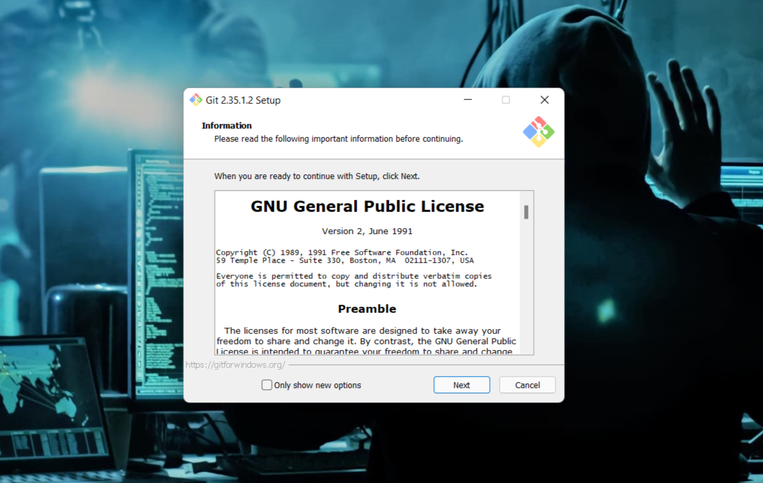

Click on Next

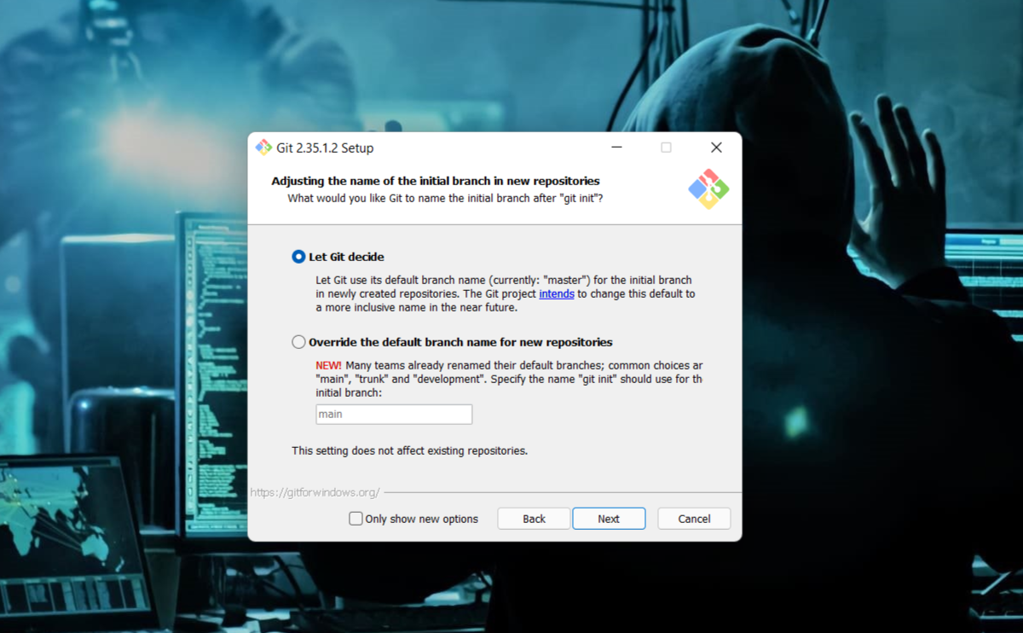

Continue clicking on next few times more

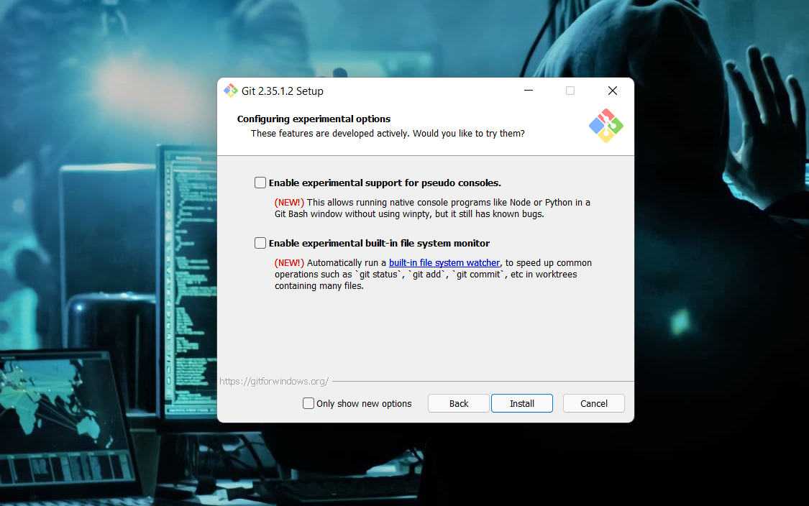

Now select the Install option.

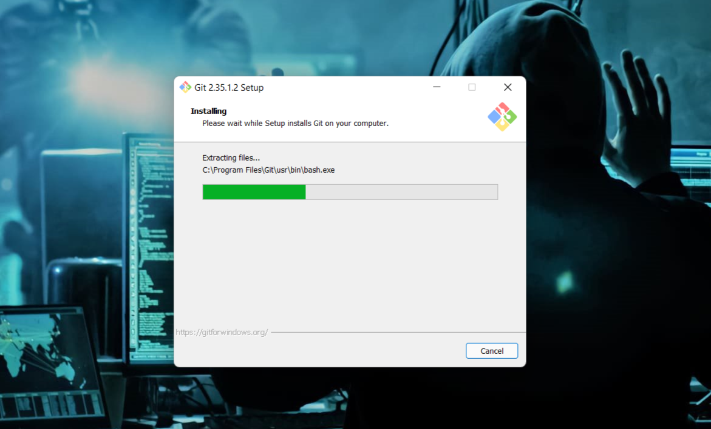

Click on Finish after the installation is finished.

The installation of the git is finished and now we have to setup git client and GitHub account.

SETTING UP GITHUB ACCOUNT

Open your web browser search GitHub login.

Click on Create an account if you are a new user or if you have already an account, please login.

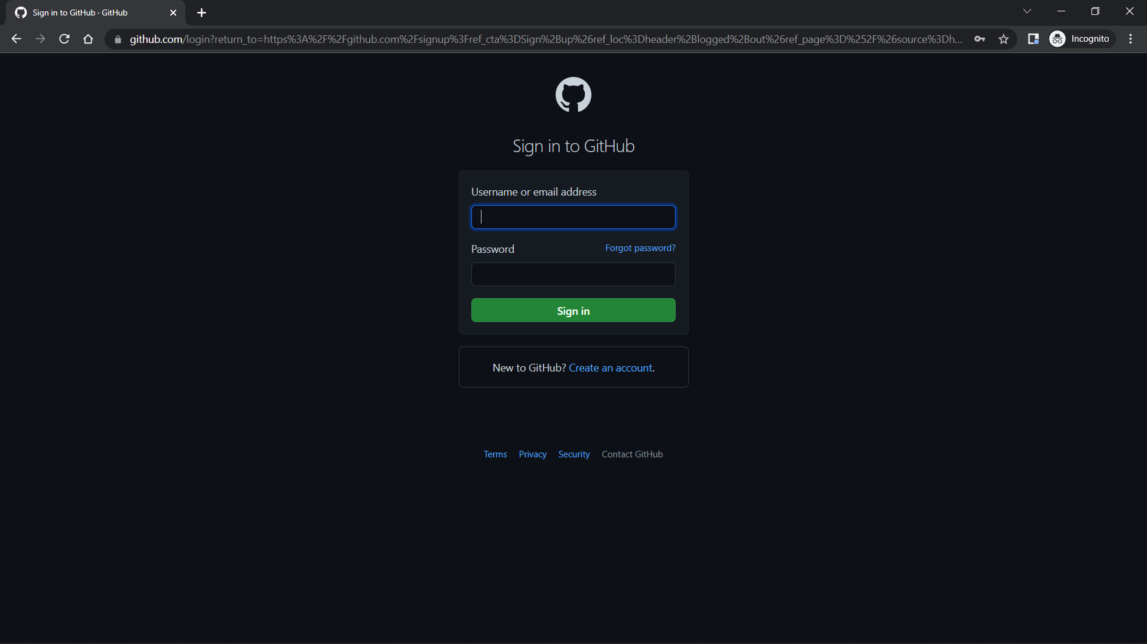

After clicking on "Create a New Account," you will be sent to a new page where you must enter your email address for your account. Now type in the password you'd want to use for your GitHub account. Then you'll be prompted to enter your username.

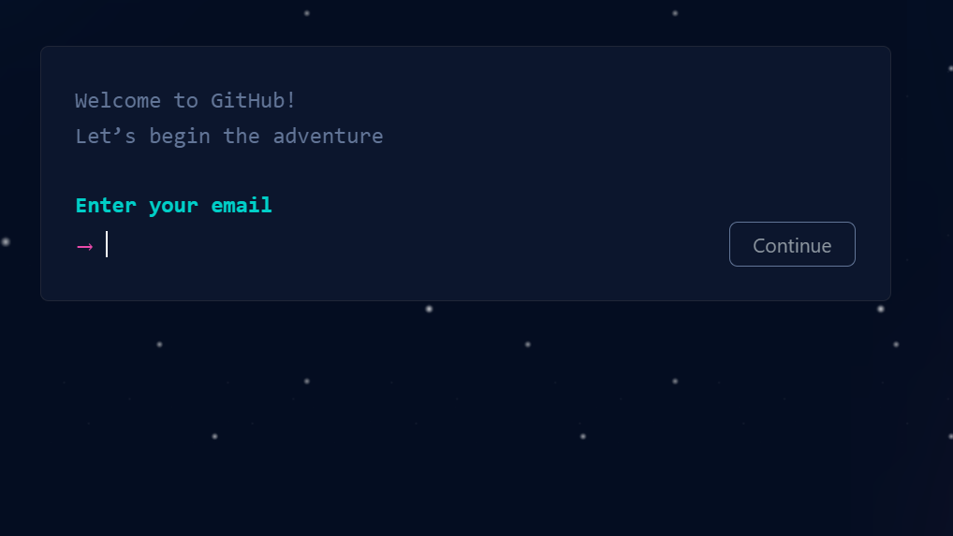

Now Click on Create Account.

Verify it from your email and you are all set to go.

USING GIT COMMANDS

### SETTING USER-NAME AND EMAIL



Mkdir: It is used for creating a directory using Git Bash.

cd command: Both Bash and Windows console host have a cd command. cd is an acronym for 'Change Directory'. cd is invoked with an appended directory name. Executing cd will change the terminal sessions current working directory to the passed directory argument.

Pwd: The Bash command pwd is used to print the 'present working directory'. This is the folder or path that the current Bash session resides in.

ls: The Bash command ls is used to 'list' contents of the current working directory.

Git status: The main tool you use to determine which files are in which state is the git status command. the command tells you which branch you’re on and informs you that it has not diverged from the same branch on the server.

Git add: In order to begin tracking a new file, you use the command git add. git add is a multipurpose command — you use it to begin tracking new files, to stage files, and to do other things like marking merge-conflicted files as resolved. It may be helpful to think of it more as “add precisely this content to the next commit” rather than “add this file to the project”.

Git commit: The git commit command captures a snapshot of the project's currently staged changes. Committed snapshots can be thought of as “safe” versions of a project—Git will never change them unless you explicitly ask it to. Prior to the execution of git commit, The git add command is used to promote or 'stage' changes to the project that will be stored in a commit. These two commands git commit and git add are two of the most frequently used.

Git push: When you have your project at a point that you want to share, you have to push it upstream. The command for this is simple: git push . If you want to push your master branch to your origin server (again, cloning generally sets up both of those names for you automatically), then you can run this to push any commits you’ve done back up to the server

git push origin master

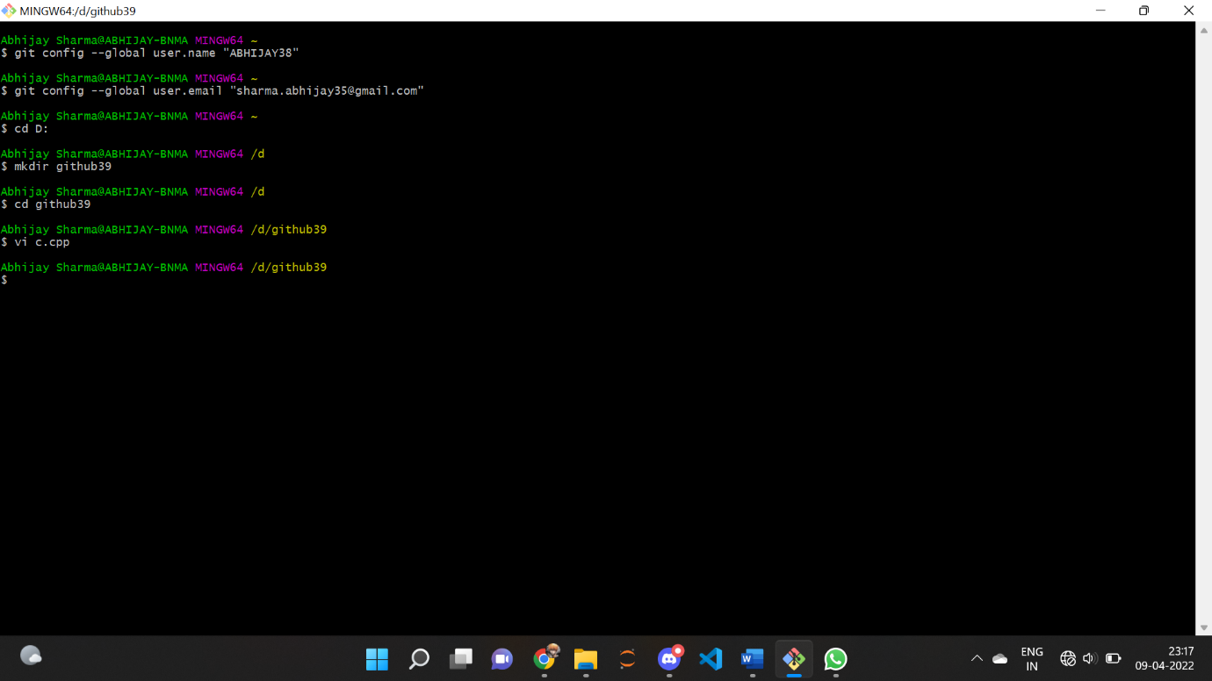

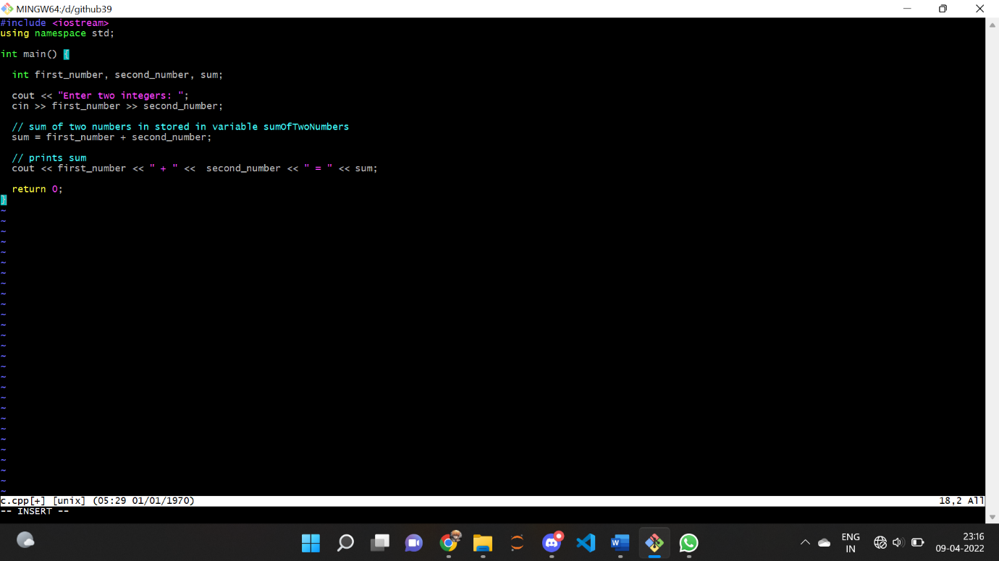

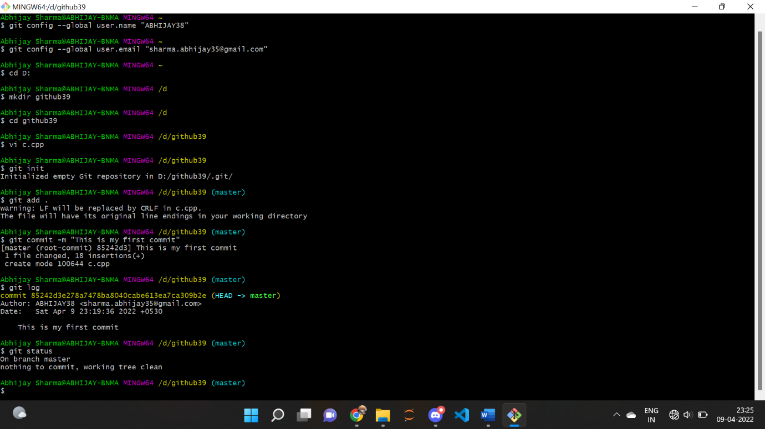

GENERATE LOGS

Logs are nothing but the history which we can see in Git by using the code Git log. It contains all the past commits, insertions and deletions which can be seen anytime

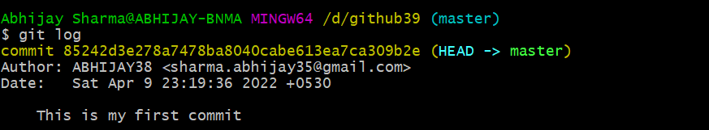

GIT BRANCHING

A branch in Git is an independent line of work(a pointer to a specific commit). It allows users to create a branch from the original code (master branch) and isolate their work. Branches allow you to work on different parts of a project without impacting the main branch.

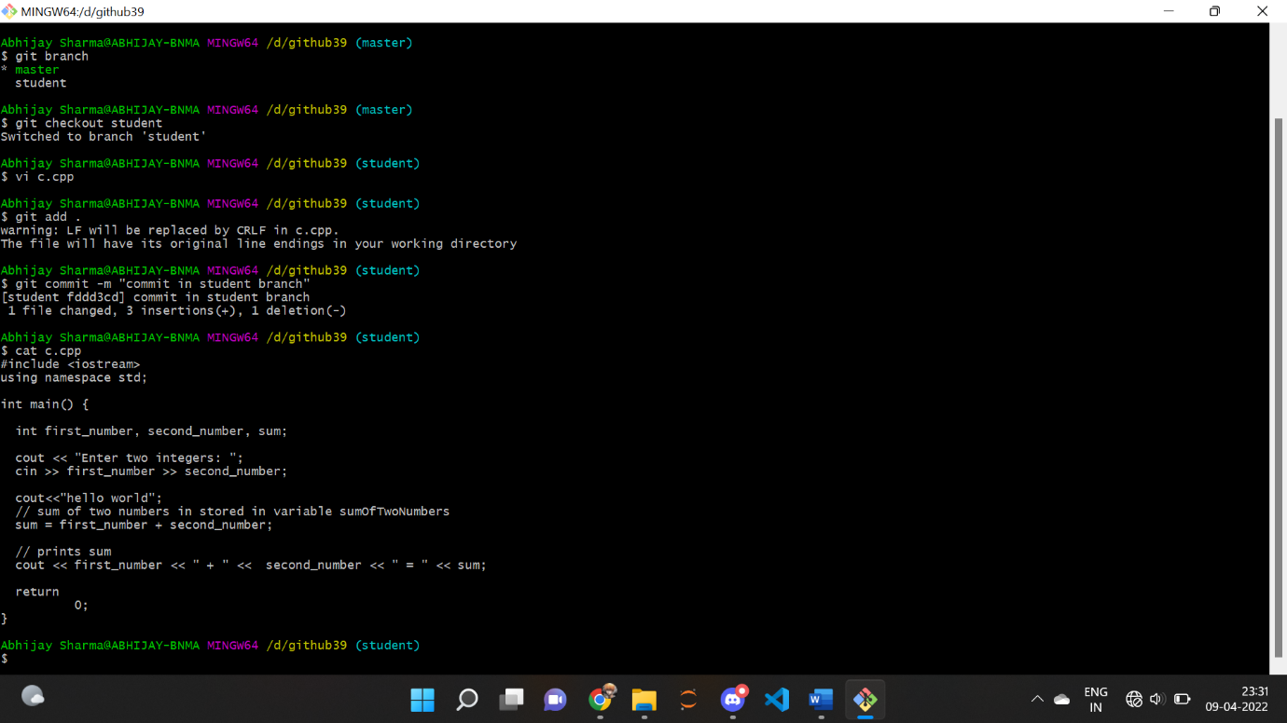

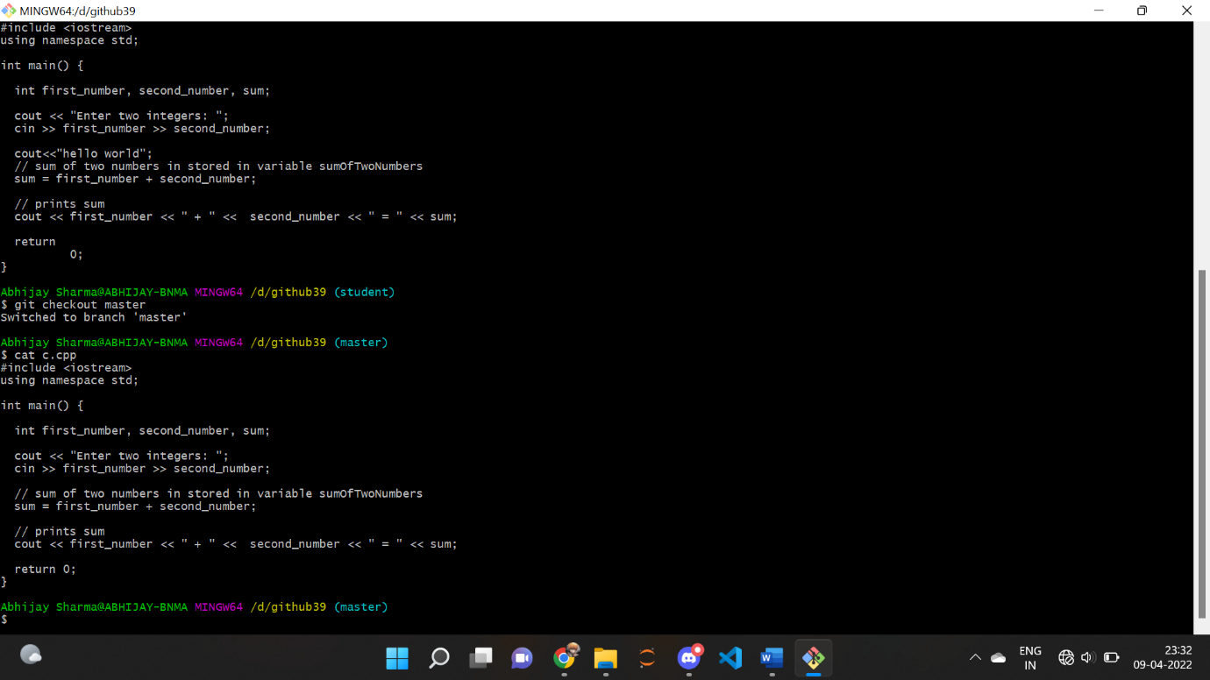

GIT LIFECYCLE DESCRIPTION

* **Working Directory:** This is the directory that we’ve initialized, and here all the changes are made to commit on GitHub.
* **Staging Area:** This is where we first put out code or files of the working repository. The command that we use to stage code is, “git add --a”, “git add File-Name” or “git add -A”. In simple terms, staging means telling Git what files we want to commit (new untracked files, modified files, or deleted files).

**Git directory(repository):** This is where all the commits are stored whenever we make a commit. We can revert to an older version of or project using the “git checkout” command from this directory

**Remote Repository:**

Means mirror or clone of the local Git repository in GitHub. And pushing means uploading the commits from local Git repository to remote repository hosted in GitHub. 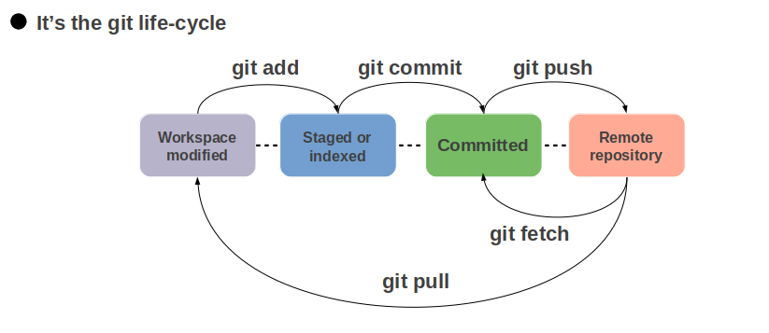

TASK 1.2

ADD COLLABORATORS ON GITHUB REPOSITORY:-

1. Ask for the username of the person you're inviting as a collaborator. If they don't have a username yet, they can sign up for GitHub For more information, see "[Signing up for a new GitHub account](https://docs.github.com/en/articles/signing-up-for-a-new-github-account)".
2. On GitHub.com, navigate to the main page of the repository.
3. Under your repository name, click  **Settings**.
4. In the "Access" section of the sidebar, click **Collaborators & teams**.
5. Click **Invite a collaborator**.
6. In the search field, start typing the name of person you want to invite, then click a name in the list of matches.
7. Click **Add NAME to REPOSITORY**.
8. The user will receive an email inviting them to the repository. Once they accept your invitation, they will have collaborator access to your repository.

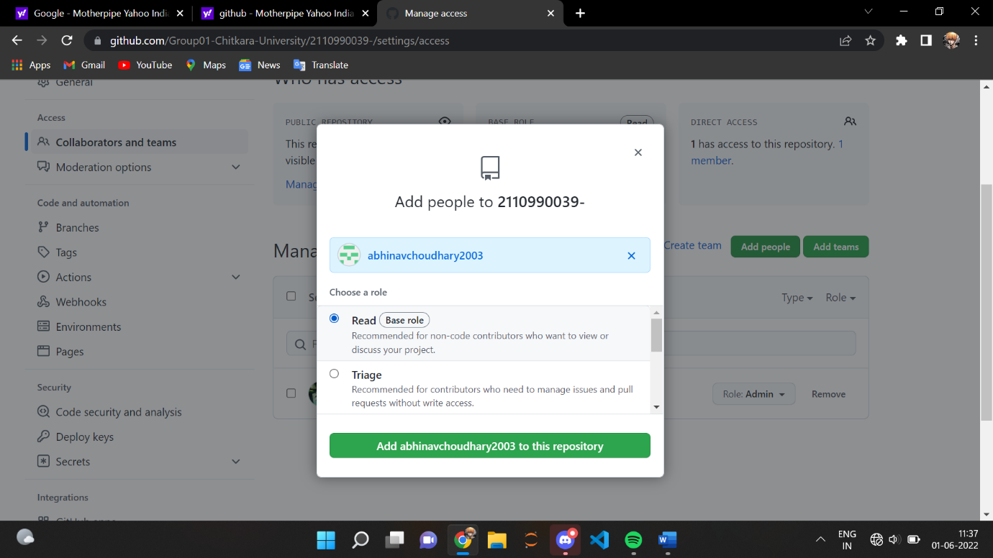



FORK AND COMMIT IN GIT

A fork is a copy of a repository. Forking a repository allows to freely experiment with changes without affecting the original project.

STEPS:

1. Go to the repository that you wish to fork.
2. Click on the option ‘Fork’ in the top right corner



1. Name your forked repository and click on ‘Create New Fork’.
2. You now have a forked repository.

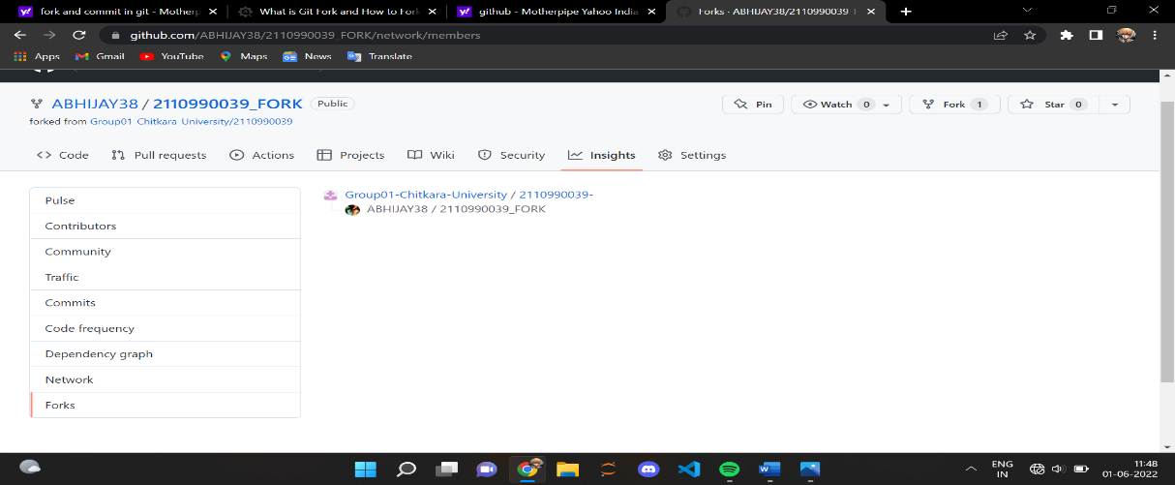

## CLONING THE REPO INTO YOUR DEVICE

When you create a repository on GitHub.com, it exists as a remote repository. You can clone your repository to create a local copy on your computer and sync between the two locations.

1. Once you have forked the repository, you can clone it into your computer using directly the option given on GitHub or through running git clone command in git bash.
2. Copy the URL of the forked repository
3. Open git bash and type the command “git clone <URL of the forked repository>”

## COMMITING CHANGES TO THE FORKED REPOSITORY

1. Once you have cloned the repository you can introduce changes to it as per your wish.

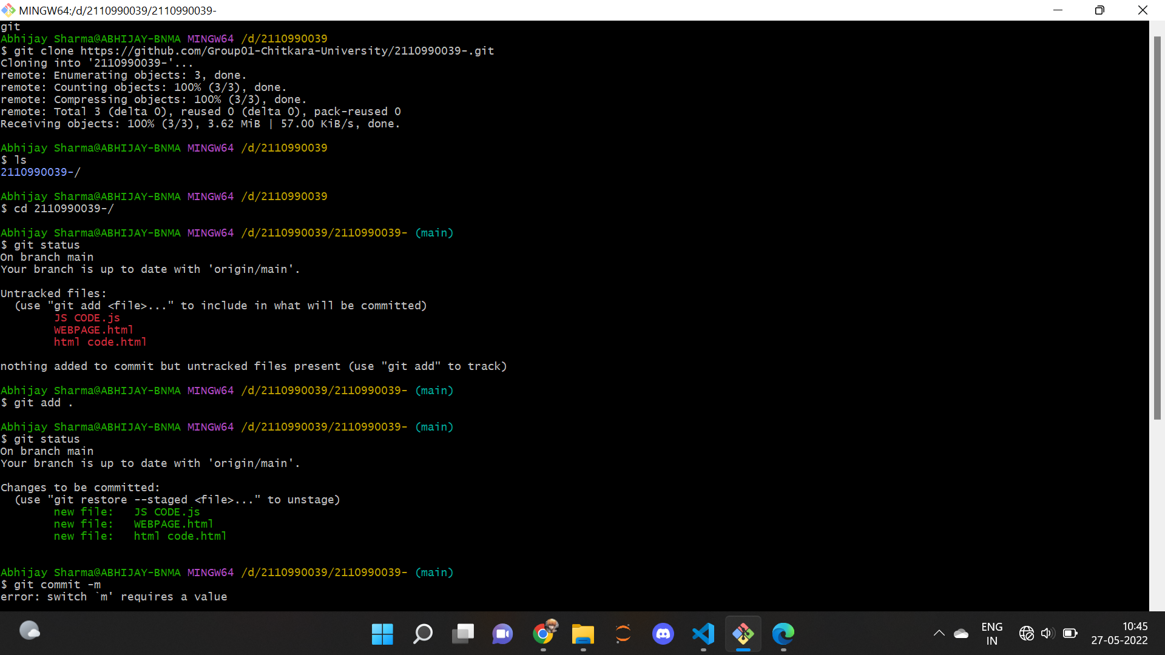

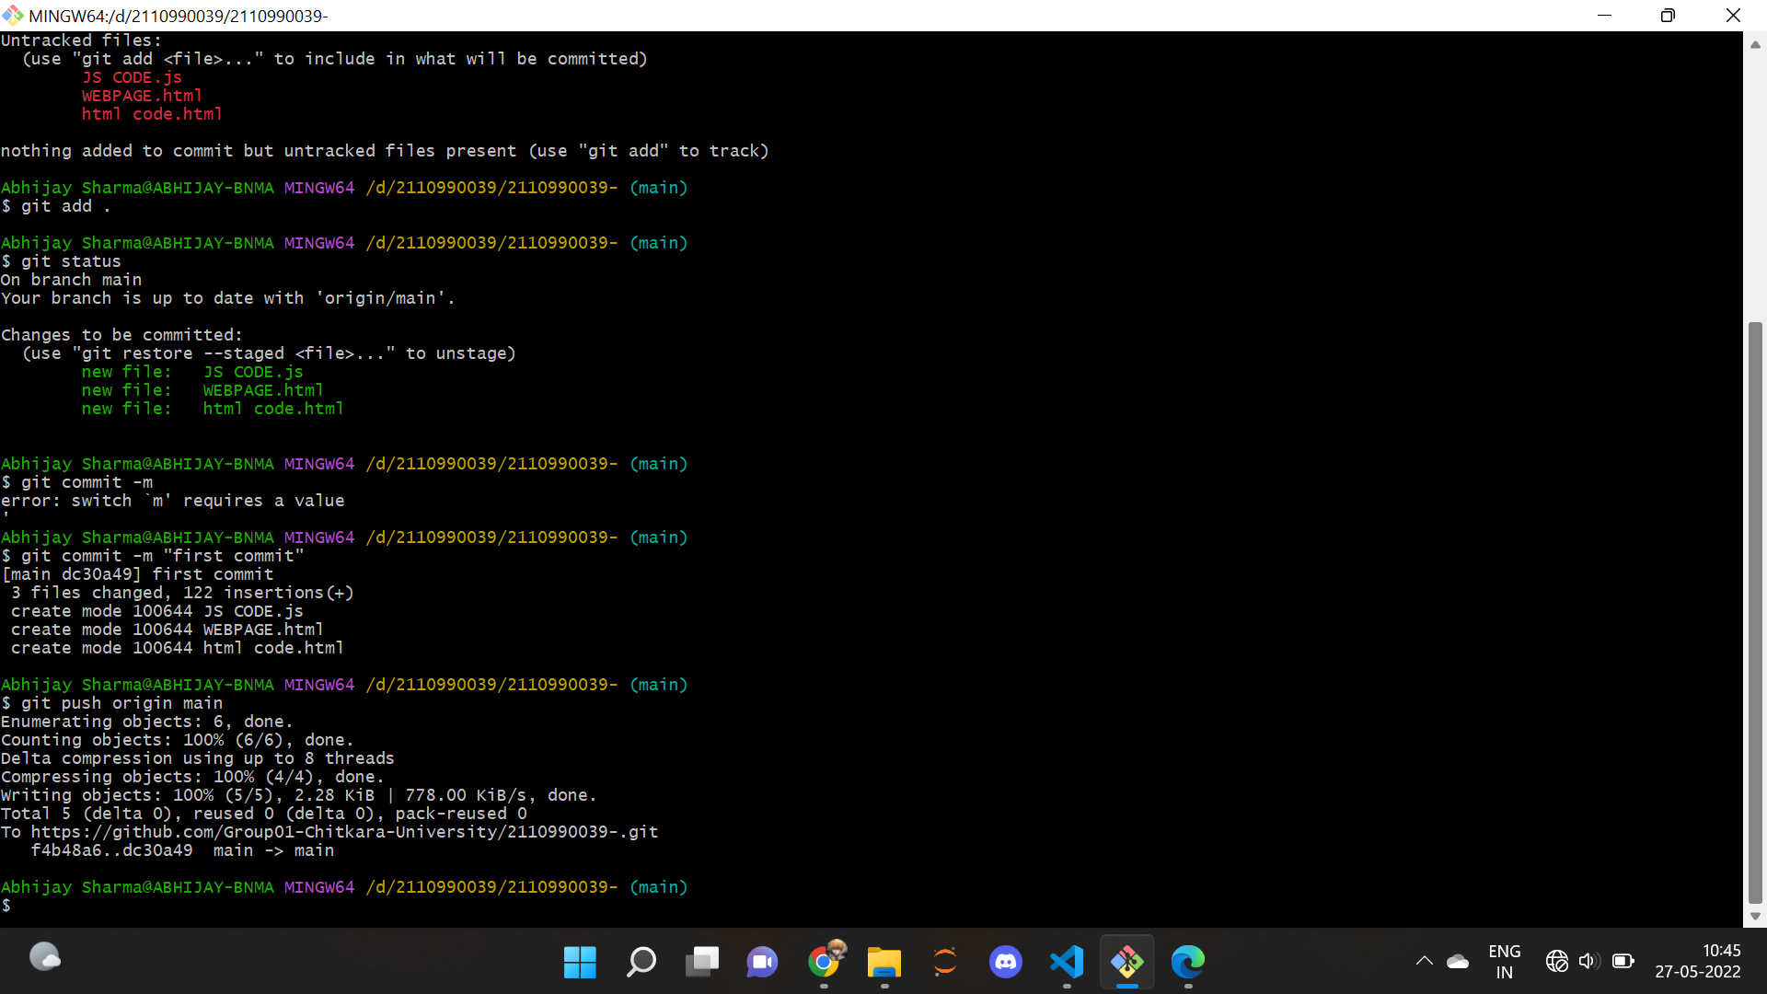

# **MERGE AND RESOLVE CONFLICTS CREATED DUE TO OWN ACTIVITY AND COLLABORATORS ACTIVITY**

Merging and conflicts are a common part of the Git experience. Conflicts generally arise when two people have changed the same lines in a file, or if one developer deleted a file while another developer was modifying it. In these cases, Git cannot automatically determine what is correct. Conflicts only affect the developer conducting the merge, the rest of the team is unaware of the conflict. Git will mark the file as being conflicted and halt the merging process. It is then the developers' responsibility to resolve the conflict.

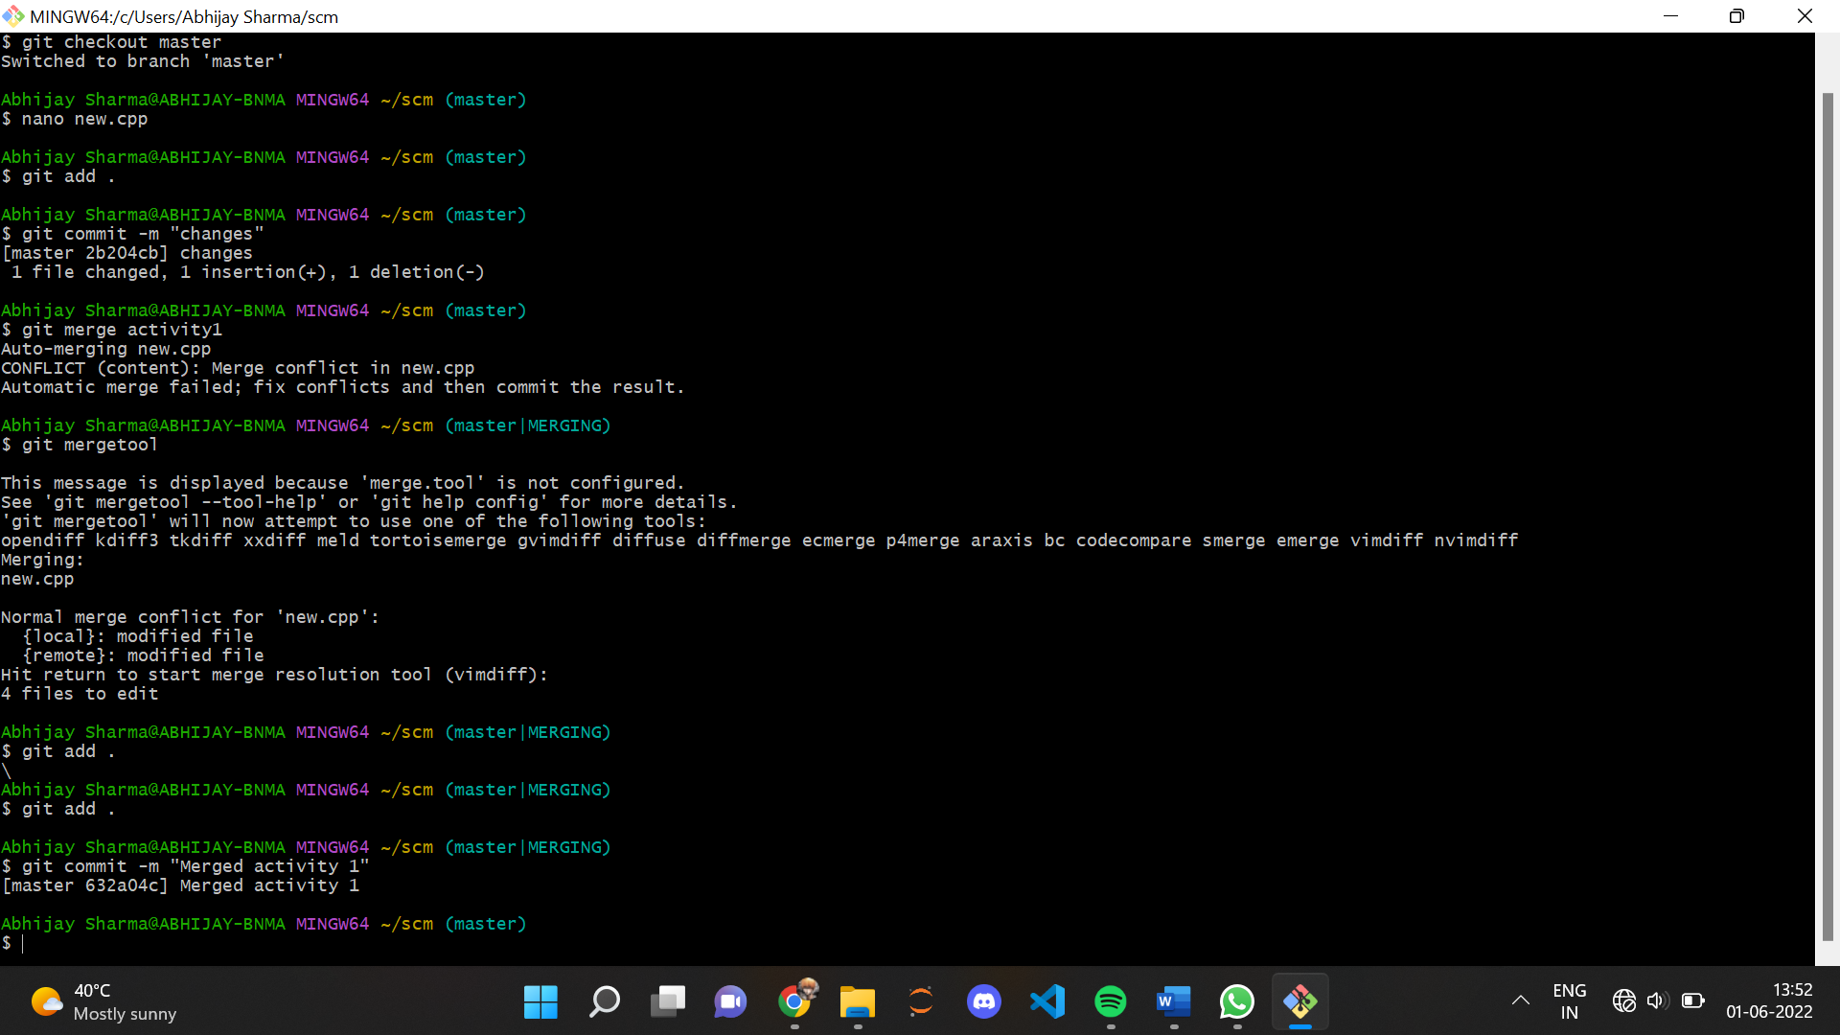

# **CREATE A DISTRIBUTED REPOSITORY AND ADD MEMBERS IN PROJECT TEAM**

1. On the homepage of your GitHub account, click on Repositories option in the menu bar.
2. Click on the ‘New’ button in the top right corner.

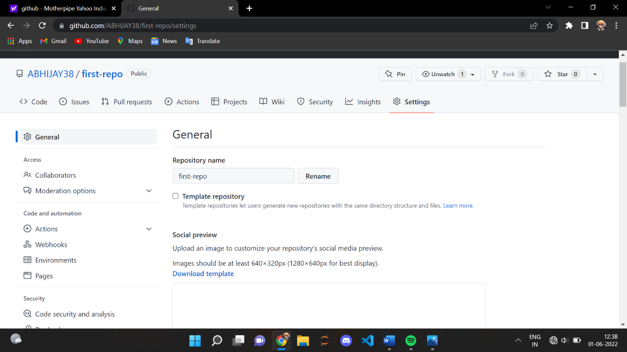

1. Enter the Repository name and add the description of the repository.
2. To add members to your repository, open your repository and select settings option in the navigation bar.
3. Click on Collaborators option under the access tab.

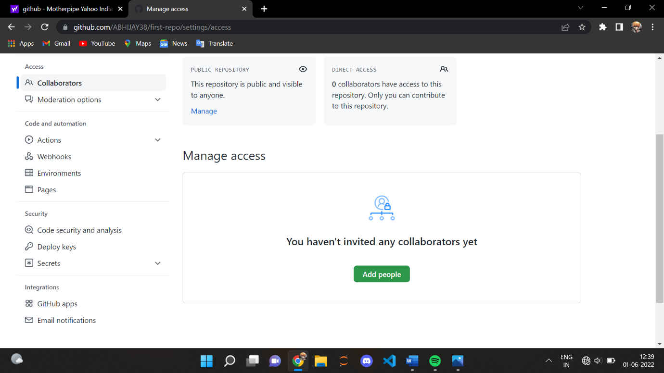

1. You can manage access and add/remove team members to your project.
2. To add members, click on the add people option and search the id of your respective team member.

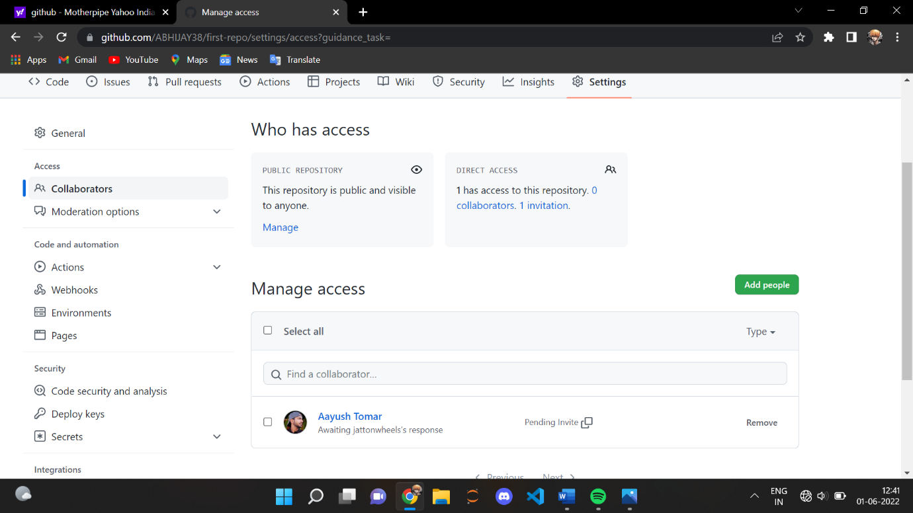

9.You will receive an invitation mail from the repository owner. Open the email and click on accept invitation.

10.You will be redirected to GitHub where you can either select to accept or decline the invitation.

Similarly, you can add more collaborators to your project.

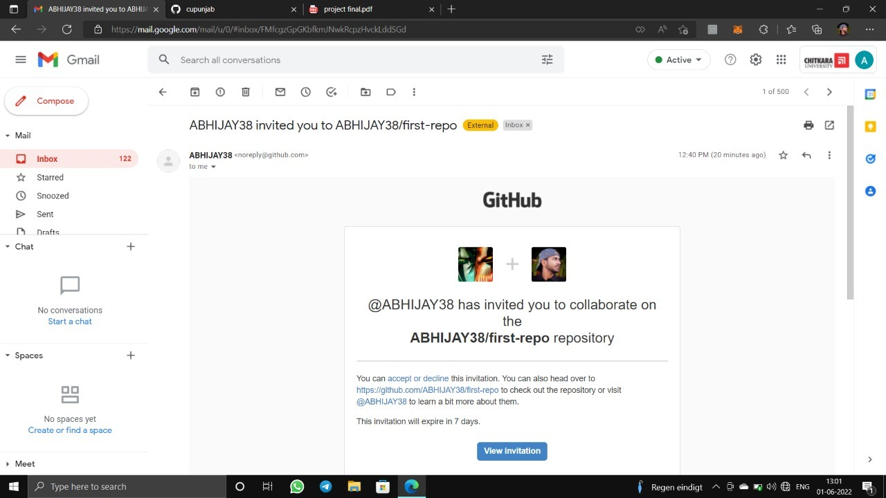

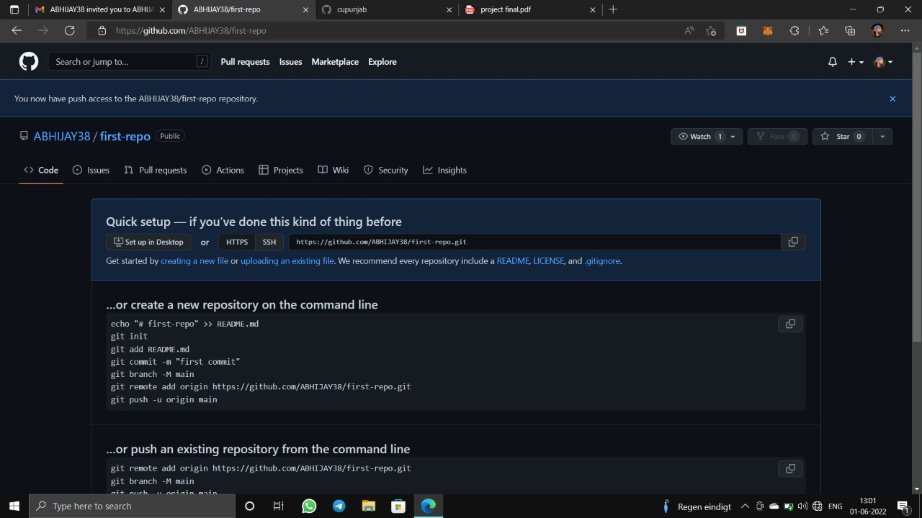

# **OPEN AND CLOSE A PULL REQUEST**

1. First, select a repository of the other person in which you want to make changes and create a pull request.

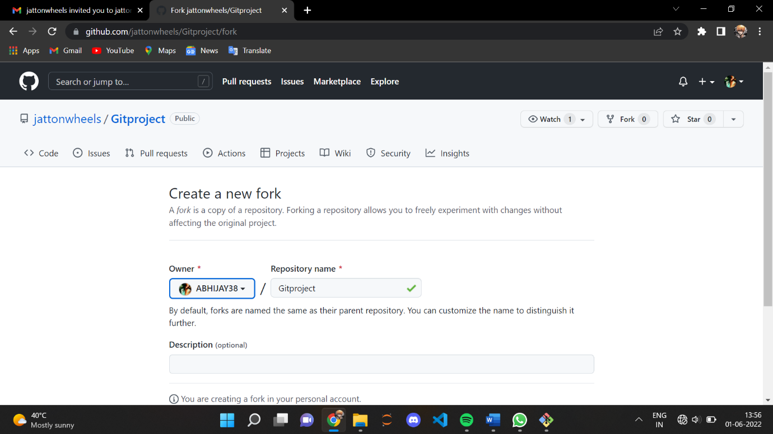

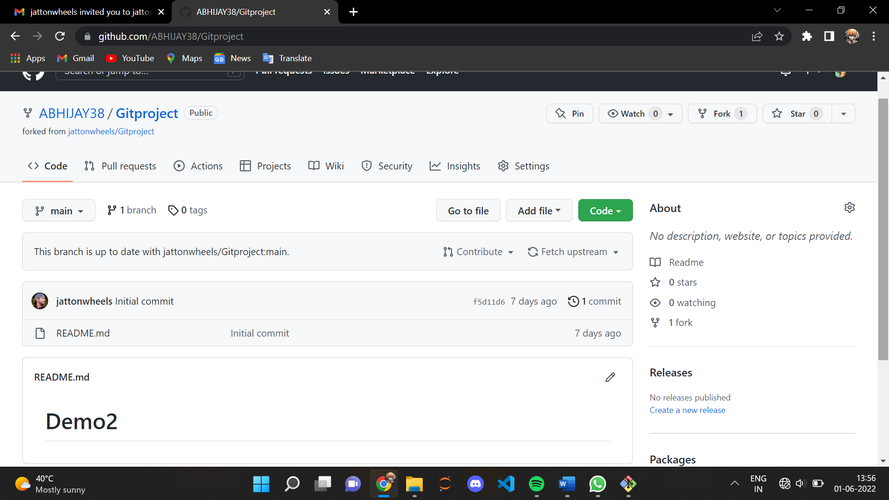

1. Clone it into your local storage.
2. To open a pull request we first have to make a new branch, by using git checkout -b *branch name* option.

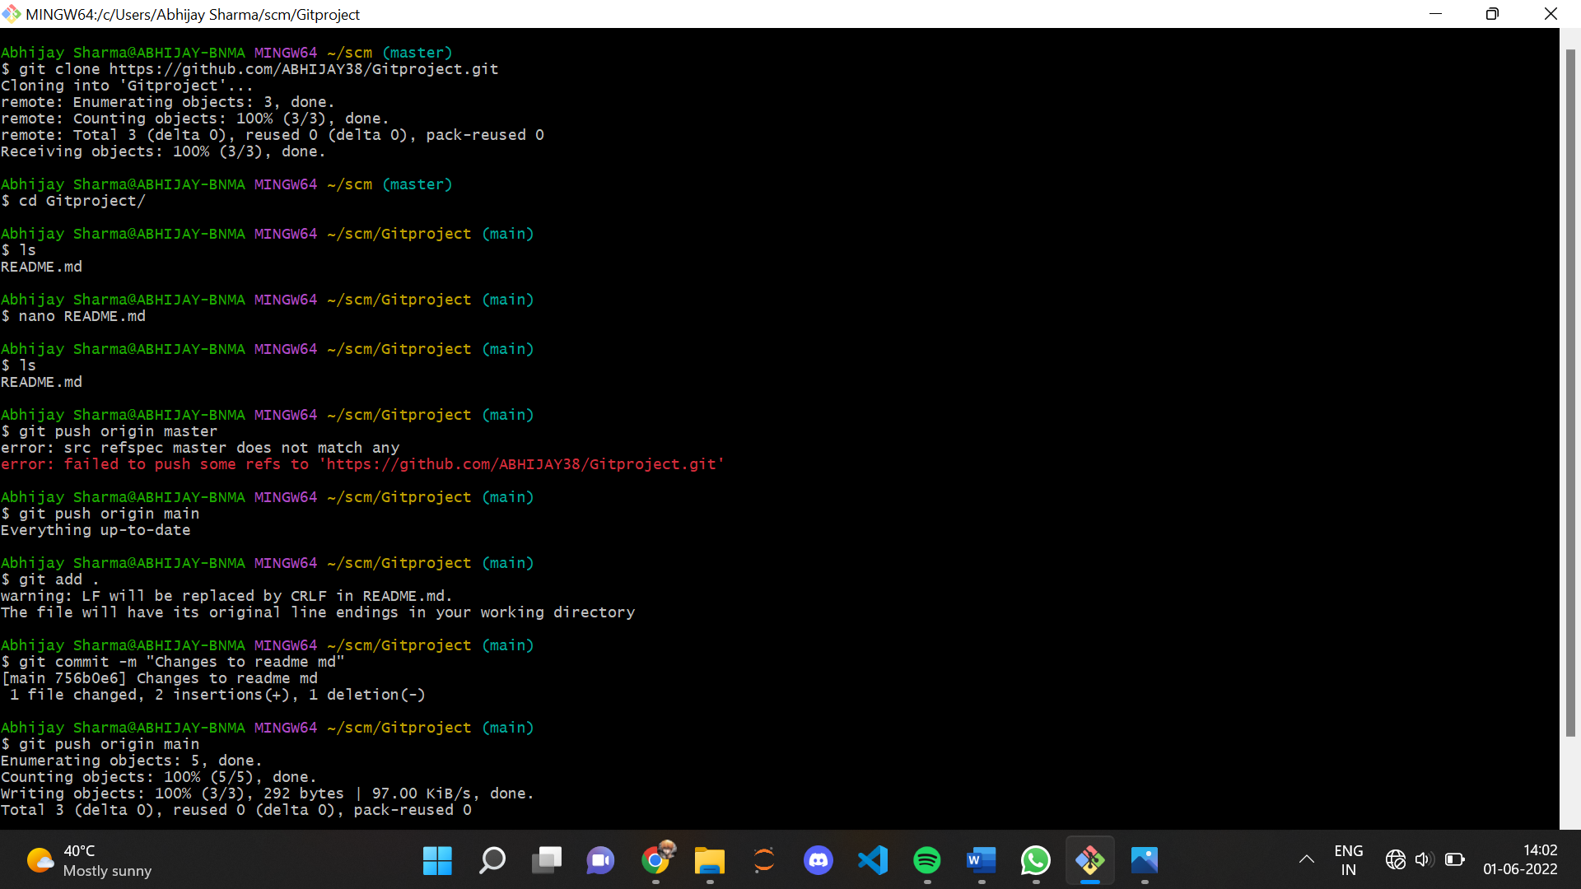

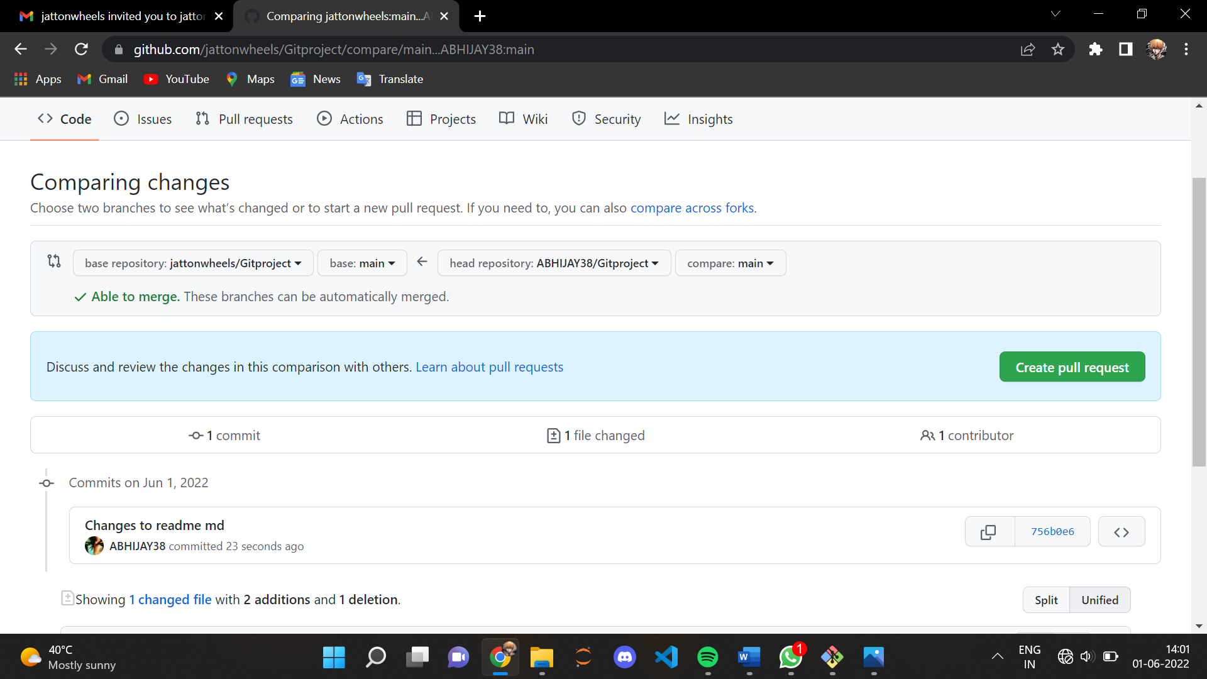

1. After making new branch we add a file to the branch or make changes in the existing file.
2. Add and commit the changes to the local repository.

# **RESET AND REVERT**

While Working with Git in certain situations we want to undo changes in the working area or index area, sometimes remove commits locally or remotely and we need to reverse those changes. We can do it by using the git reset, git revert, git checkout commands.

RESET-

git reset is used when we want to unstage a file and bring our changes back to the working directory. git reset can also be used to remove commits from the local repository.

Suppose we make edits to a file, stage it and commit it.

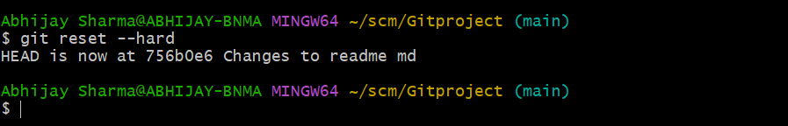

REVERT-

git revert is used to remove the commits from the remote repository. git revert removes the commit that we have done but adds one more commit which tells us that the revert has been done.

In order to understand it add changes to a file, stage and commit it.

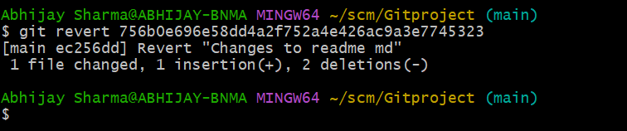

# **NETWORK GRAPHS**

To view the network graphs of your repository, follow the steps:

1. Go to the repository of which you want the graph/details.
2. Click on the ‘Insights’ option it the menu bar.
3. In the right menu list click on network.
4. You can see the network graph there.

It shows the timeline of the most recent commits to this repository and its network ordered by most recently pushed to.

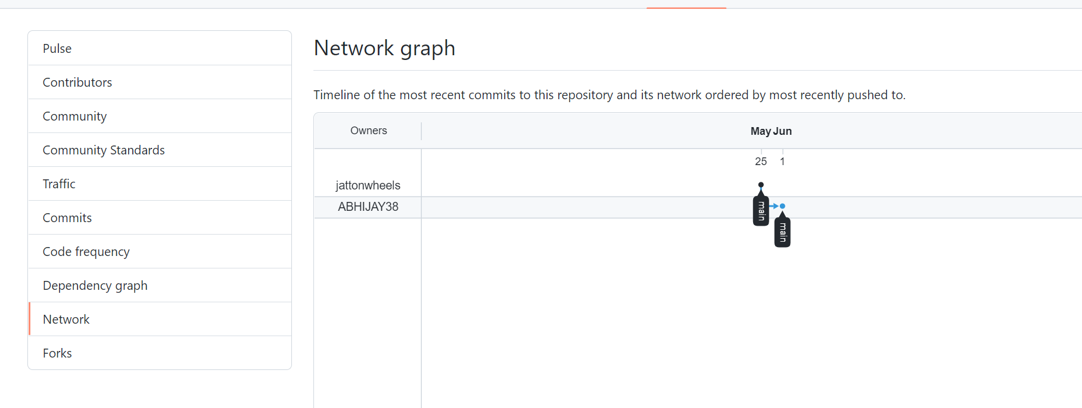



SCM PROJECT

***CREATE A DISTRIBUTED REPOSITORY AND  ADD MEMBERS IN PROJECT TEAM***

1. On the homepage of GitHub  account, click on Repositories option in

the menu bar.

2. Click on the ‘New’ button in the top right  corner.

3. Enter the Repository name and add the  description of the repository.

4. To add members to your repository, open  your repository and select settings option

in the navigation bar.

5. Click on Collaborators option under the  access tab.

6. You can manage access and add/remove  team members to your project.

7. To add members, click on the add people  option and search the id of your

respective team member.

OPEN AND CLOSE A PULL REQUEST:-

1. First, select a repository of the other person in which you want

to make changes and create a pull request.

2. Clone it into your local storage.

3. To open a pull request we first have to make a new branch, by using git

checkout -b branch name option.

4. After making new branch we add a file to the branch or make changes

in the existing file.

1. Add and commit the changes to the local repository.

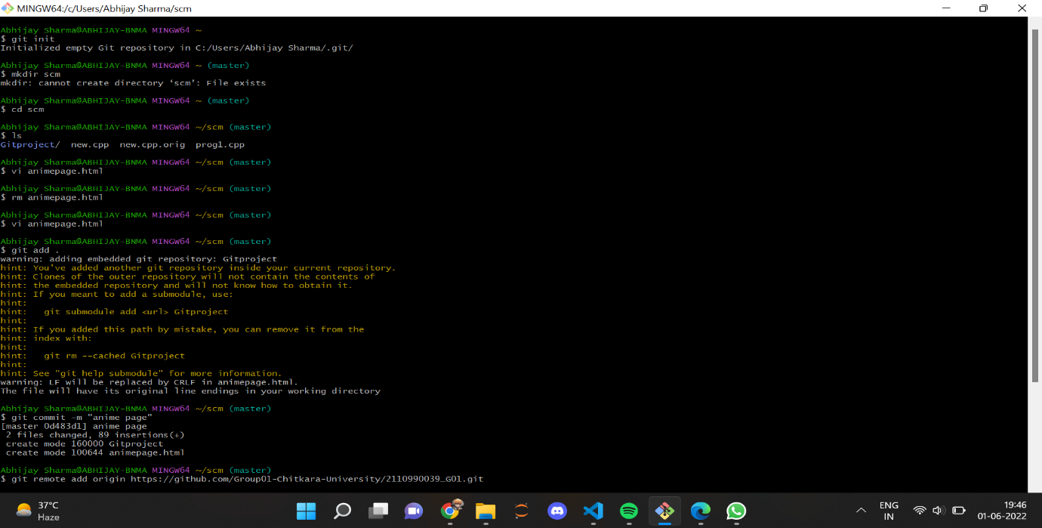

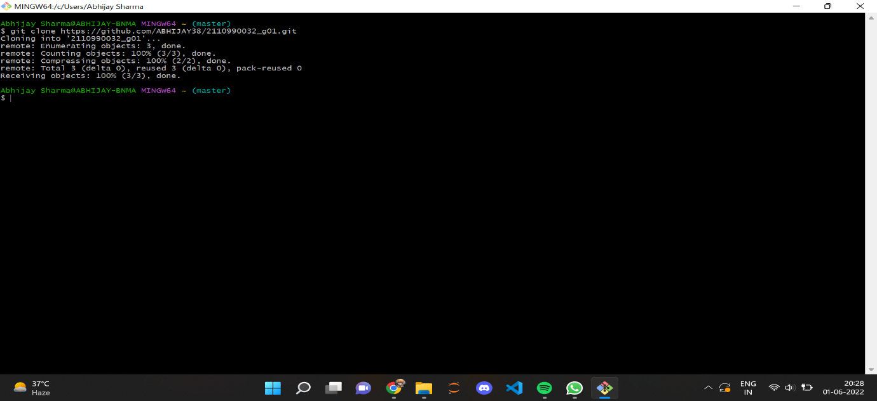

6. Use git push origin branch name option to push the new branch to the

main repository.

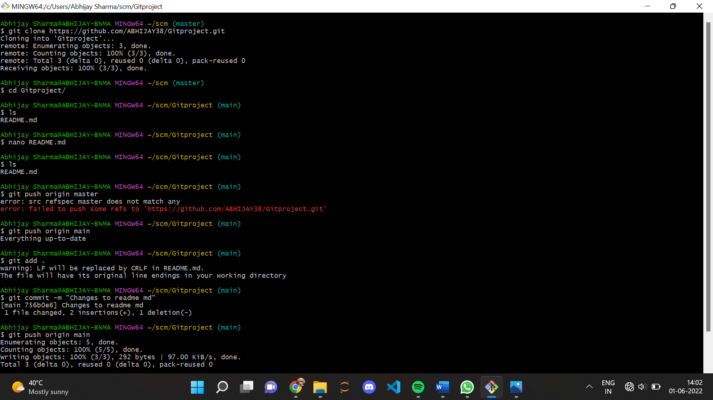

7. After pushing new branch GitHub will either automatically ask you to

create a pull request or you can create your own pull request.

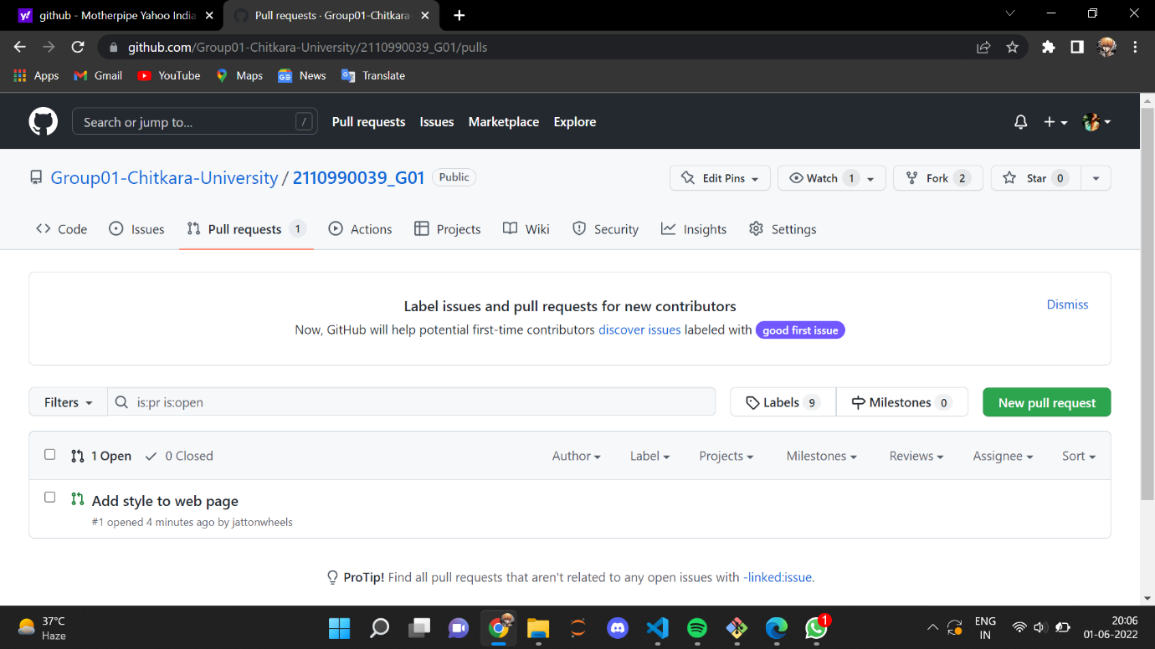

9. GitHub will detect any conflicts and ask you to enter a description of your

pull request.

10.After opening a pull request the owner of the original repository will be

sent the request if they want to merge or close the request.

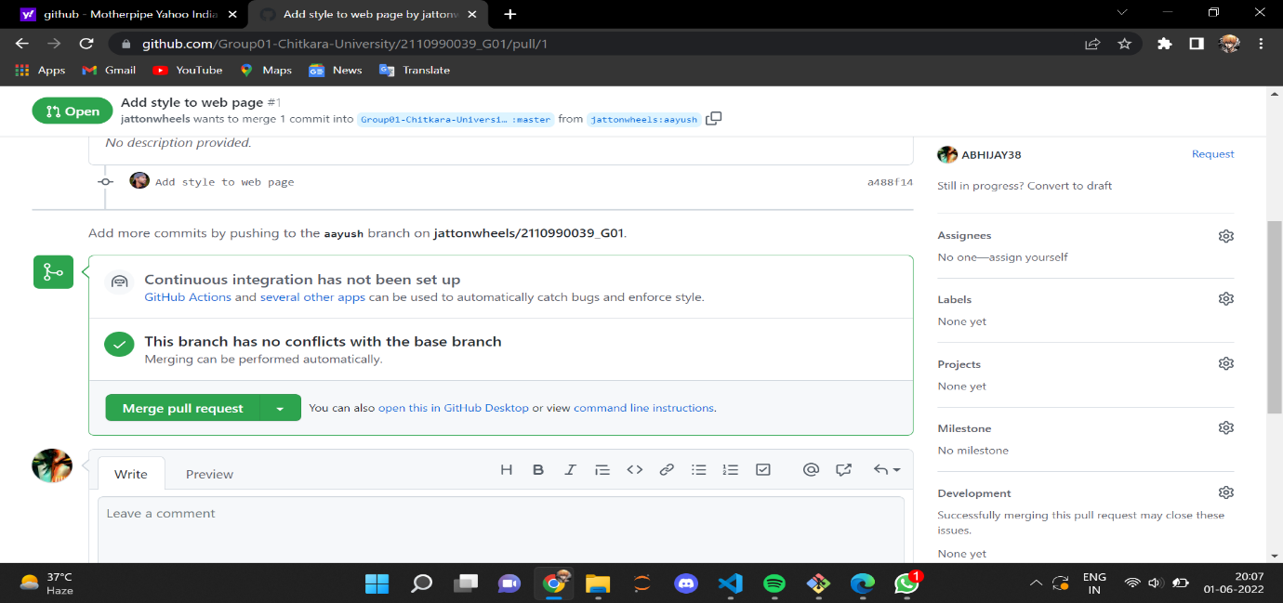

11.If the owner chooses not to merge your pull request, they will close it.

12.To close the pull request simply click on close pull request and add

comment/ reason why you closed the pull request.

13.If you want to merge it into the original, click on merge pull request.

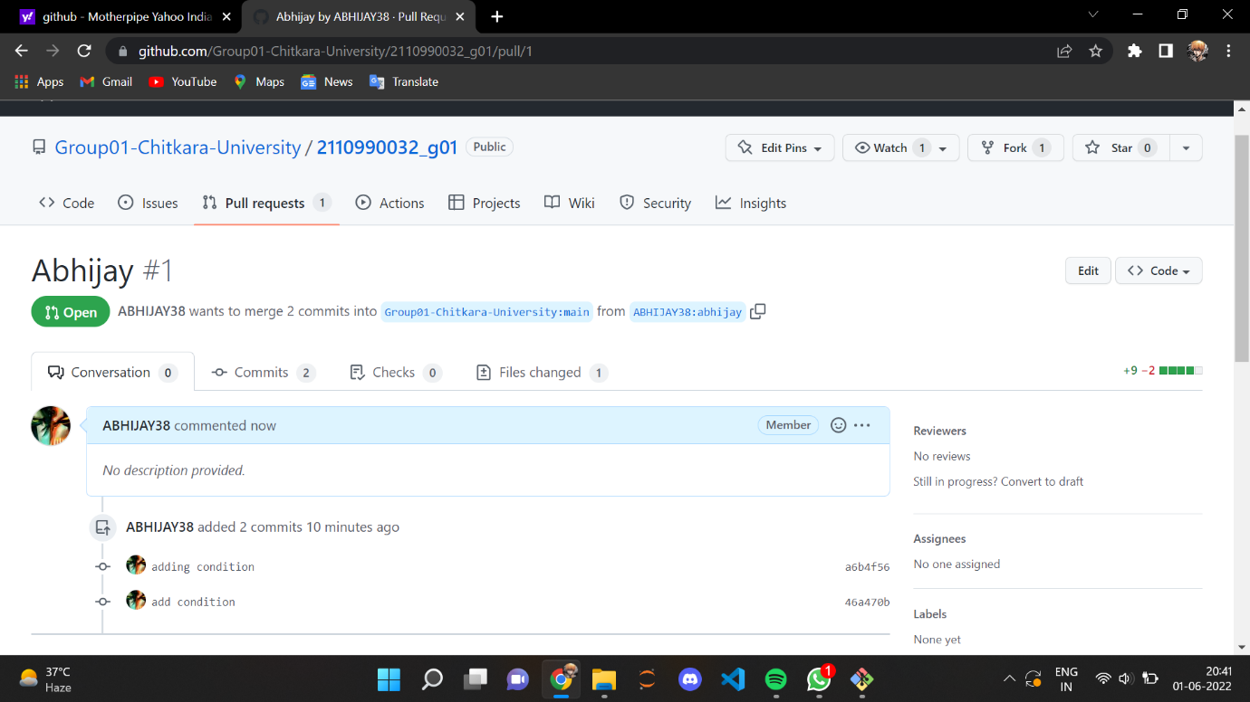

CREATE A PULL REQUEST ON A TEAM MEMBER’S REPO AND CLOSE PULL REQUESTS GENERATED BY TEAM MEMBERS ON OWN REPOSITORY AS A MAINTAINER

#OPENING PULL REQUESTS ON TEAM MEMBER’S REPOSITORY

1. Do the required changes in the repository, add and commit

these changes in the local repository in a new branch.

2. Push the modified branch using git push origin

branchname.

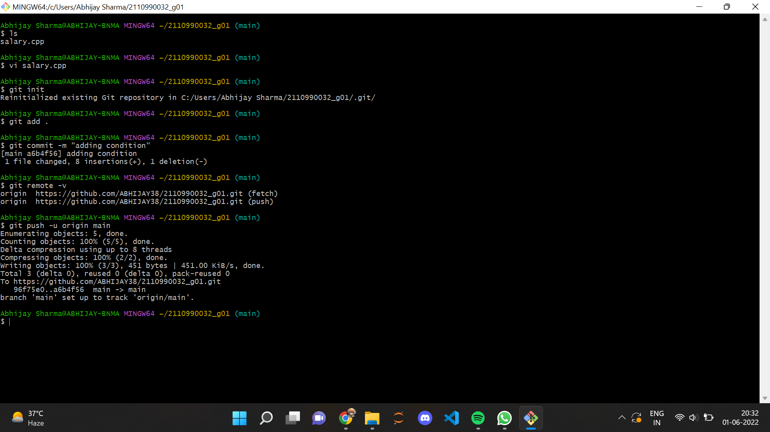

3. Open a pull request by following the procedure from

the above experiment.

4.The pull request will be created and will be visible to

all the team members.

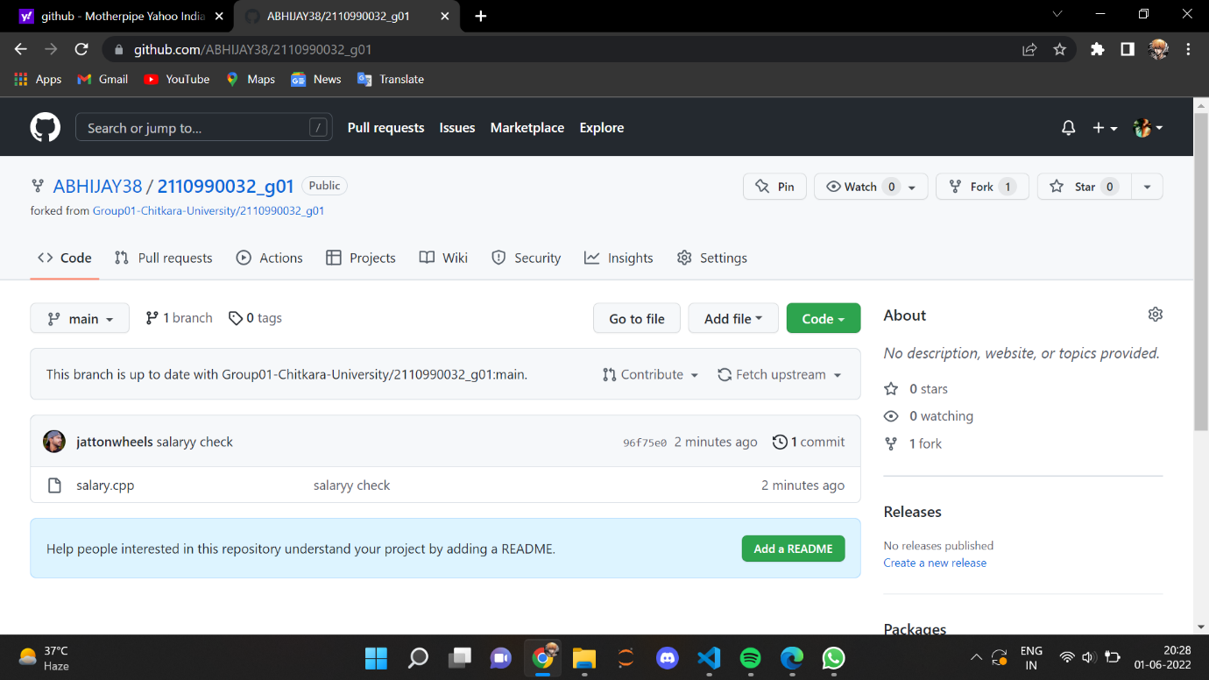

5. Click on compare & pull request option appearing at

the top.

6 .After you enter a description, click on the open

request button.

7. Pull request has been sent to your team member. They

can choose to either close the pull request or merge it.

8. Suppose they merged it, then the changes you made to

the forked repository will be introduced into the

owner’s original repository and you will be notified

about merging.

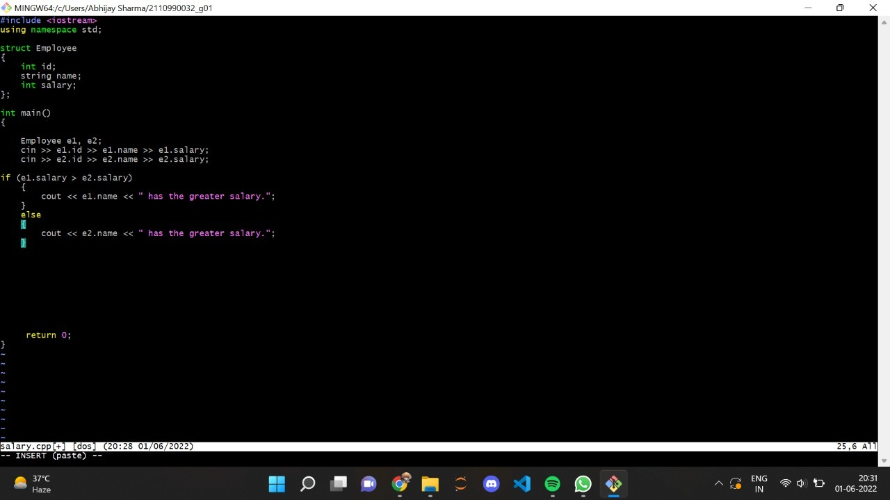

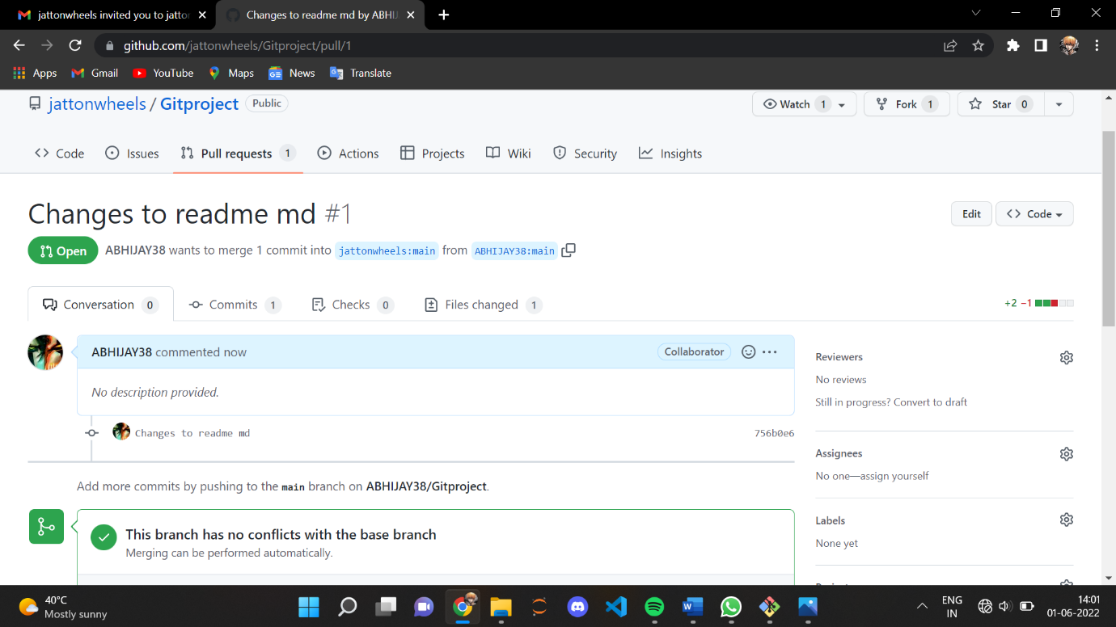

Similarly, create pull requests on other members

repositories.

THANK YOU